e

ANNUAL REPORT 2023

AIR FORCE SCHOOL HEBBAL

POSTAL ADDRESS
HQTC(U), JC Nagar Post, Hebbal, Bengaluru, Karnataka- 560006.

EMAIL
afshebbal@gmail.com

WEBSITE
http://www.afshebbal.ac.in/

TELEPHONE NUMBERS
080-23411081
Extn :7955 &4506

AFFILIATION STATUS PERIOD
REGULAR

ACHIEVEMENTS OF STUDENTS OF AFSH
- Our little champion Tanvi has bagged a Gold Medal in Karnataka Second Mini Olympics 2022 , Silver Medal in the 23nd Sub-Junior National Fencing Championship 2022
- Saiesh Kini student of class VIII has won a Bronze medal in CBSE Swimming South Zone II 2022-23 conducted by NPS AGARA Bangalore and 2 Silver Medals in Aeries Swimming Meet 2022.
- Srushti Sandeep student of class VIII and Padmini Singh student of class IX has been selected for an Inspire Award for the year 2022-23.
- Harshal Singh of class XII has bagged a Bronze medal in CBSE Cluster Athletics Championship 2022-23.
- Akshay Seth of Class XII has bagged 5 Gold Medals in CBSE Swimming South ZoneII, 2 Gold Medals in CBSE National Swimming Competition 2022-23 Conducted in Rajkot Gujarat and 3 Silver Medals in State Sub Junior and Junior Swimming Championship under 17 2022.
- Divyam Gandhi and Kushal of class VIII, has been selected in Top 100 teams in Tinkerpreneur 2022 for their project PROGRAVERSE.

ATL COMMUNITY CHALLENGE

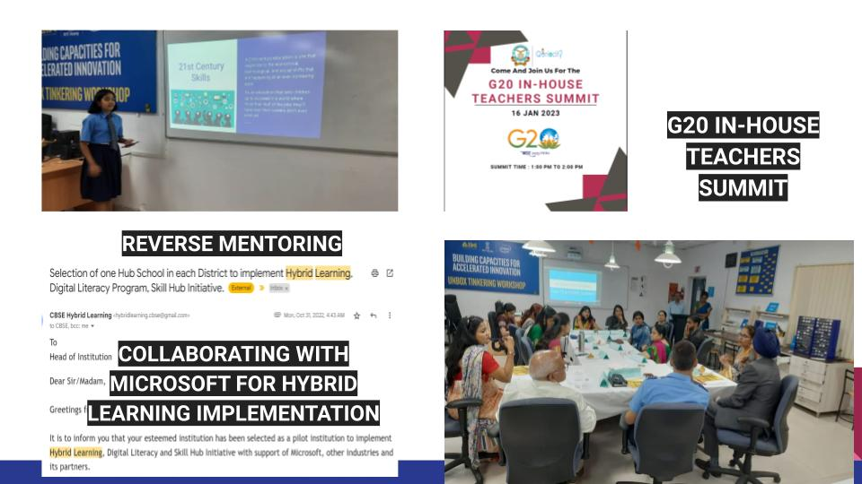

DETAILS OF INFRASTRUCTURE

 | Total number
School site | 1
Playgrounds | 2
Building blocks in school | 6
Total number of rooms | 54
- Large sized rooms | 12
- Medium sized rooms | 18
- Small sized rooms | 12
Activity room | 2
Auditorium | 1
No. of laboratories | 6
Library | 1
Toilets | 60
- Female restrooms | 2
- Female staff washroom | 2
- Girls toilet | 24
- Male restroom | 1
Male staff washroom | 1
- Boys toilet | 36

OTHER FACILITIES
Total no. of water purifiers /RO | 07
Total computers | 98
Web server | yes
Provision for web-based learning programs | yes
WIFI enabled | yes
CCTV Camera | yes
Strong room | yes
Indoor games facility | yes
Dance/ Music facility | yes
Fire alarms | yes
Sprinklers | yes
Fire extinguishers | yes
Sufficient No. of guards | yes

ACADEMIC CALENDAR

APRIL
SUN | MON | TUE | WED | THUR | FRI | SAT
 |  |  |  |  |  | 1
2 | 3 | 4 | 5 | 6 | 7 | 8
9 | 10 | 11 | 12 | 13 | 14 | 15
16 | 17 | 18 | 19 | 20 | 21 | 22
23 | 24 | 25 | 26 | 27 | 28 | 29
30

MAY
SUN | MON | TUE | WED | THUR | FRI | SAT
 | 1 | 2 | 3 | 4 | 5 | 6
7 | 8 | 9 | 10 | 11 | 12 | 13
14 | 15 | 16 | 17 | 18 | 19 | 20
21 | 22 | 23 | 24 | 25 | 26 | 27
28 | 29 | 30 | 31

JUNE
SUN | MON | TUE | WED | THUR | FRI | SAT
 |  |  |  | 1 | 2 | 3
4 | 5 | 6 | 7 | 8 | 9 | 10
11 | 12 | 13 | 14 | 15 | 16 | 17
18 | 19 | 20 | 21 | 22 | 23 | 24
25 | 26 | 27 | 28 | 29 | 30

JULY
SUN | MON | TUE | WED | THUR | FRI | SAT
 |  |  |  |  |  | 1
2 | 3(1St  periodic test) | 4 | 5 | 6 | 7 | 8
9 | 10 | 11 | 12 | 13 | 14 | 15
16 | 17 | 18 | 19 | 20 | 21 | 22(PTM)
23 | 24 | 25 | 26 | 27 | 28 | 29
30 | 31

AUGUST
SUN | MON | TUE | WED | THUR | FRI | SAT
 |  | 1 | 2 | 3 | 4 | 5
6 | 7 | 8 | 9 | 10 | 11 | 12
13 | 14 | 15 | 16 | 17 | 18 | 19
20 | 21 | 22 | 23 | 24 | 25 | 26
27 | 28 | 29 | 30 | 31

SEPTEMBER
SUN | MON | TUE | WED | THUR | FRI | SAT
 |  |  |  |  | 1 | 2
3 | 4 | 5 | 6 | 7 | 8 | 9
10 | 11 | 12 | 13 | 14 | 15 | 16
17 | 18 | 19(Perodic test 2) | 20 | 21 | 22 | 23
24 | 25 | 26 | 27 | 28 | 29 | 30

OCTOBER
SUN | MON | TUE | WED | THUR | FRI | SAT
1 | 2 | 3 | 4 | 5 | 6 | 7(PTM)
8 | 9 | 10 | 11 | 12 | 13 | 14
15 | 16 | 17 | 18 | 19 | 20 | 21
22 | 23 | 24 | 25 | 26 | 27 | 28
29 | 30(PTM) | 31

NOVEMBER
SUN | MON | TUE | WED | THUR | FRI | SAT
 |  |  | 1 | 2 | 3 | 4
5 | 6 | 7 | 8 | 9 | 10 | 11
12 | 13 | 14 | 15 | 16 | 17 | 18
19 | 20 | 21 | 22 | 23 | 24 | 25
26 | 27 | 28 | 29 | 30

DECEMBER
SUN | MON | TUE | WED | THUR | FRI | SAT
 |  |  |  |  | 1 | 2
3 | 4 | 5 | 6 | 7 | 8 | 9
10 | 11(Preboard  Exam) | 12 | 13 | 14 | 15 | 16
17 | 18 | 19 | 20 | 21 | 22 | 23
24 | 25 | 26 | 27 | 28 | 29 | 30
31

JANUARY
SUN | MON | TUE | WED | THUR | FRI | SAT
 | 1 | 2 | 3 | 4 | 5 | 6
5 | 8(Periodic test 3) | 9 | 10 | 11 | 12 | 13
12 | 15 | 16 | 17 | 18 | 19 | 20
19 | 22 | 23 | 24 | 19 | 26 | 27(PTM)
26 | 29 | 30 | 31

FEBRUARY
SUN | MON | TUE | WED | THUR | FRI | SAT
 |  |  |  | 1 | 2 | 3
4 | 5 | 6 | 7 | 8 | 9 | 10
11 | 12 | 13 | 14 | 15 | 16 | 17
18 | 19 | 20 | 21 | 22 | 23 | 24
25 | 26 | 27 | 28

MARCH
SUN | MON | TUE | WED | THUR | FRI | SAT
 |  |  |  |  | 1(Final  Exam) | 2
3 | 4 | 5 | 6 | 7 | 8 | 9
10 | 11 | 12 | 13 | 14 | 15 | 16
17 | 18 | 19 | 20 | 21 | 22 | 23
24 | 25 | 26 | 27 | 28 | 29 | 30(Result  & PTM)
31

 | NOTE
UT | UNIT TEST
PT | PERIODIC TEST FOR SECONDARY
PTM | PARENTS TEACHERS MEET
SUMMER BREAK | 3-May-2022 | 19- June-2022
AUTUMN BREAK | 03-Oct-2022 | 12-Oct-2022
WINTER BREAK | 21-Dec-2022 | 2-Jan-2023

Events | Date | Events
Earth Day activities | Apr-22 | Earth Day poems
 |  | Kavitas/posters

Secondary/ Senior Secondary CCA and Primary CCA

Yoga poses paper craft (6  -10th) | June/July- 22 | Solo dance All Classes
Solo Dance (6-8th) |  | Friendship band(Cls 1 and 2)  Group recitation (Eng/Hindi)
Friendship Bands (6-12th) | Aug-22 | Fancy Dress (Cls 1and 2)
Solo Singing (6-12th) |  | Rakhi making (Cls 3 to 5)
Mono acting (6-12th) | Sep-22 | Reading week: All Classes
Essay Writing (6-12th) |  | Friendship/Mitrata Activities
Short story Writing (8-12th) | Oct-22 | Making a Salad (Cls 1 and 2)
Mandala Art (7-12th) |  | Diya/Pulses activity (Cls  3-5)
Elocution (9-12th) | Nov-22 | Enact an Ad (Cls 1 and 2)
Toys from trash (6-9th) |  | Create an Ad (Cls 3-5)

Sanskrit recitation (6-9th) | Dec-22 | Show and Tell (Cls 1 and 2)
Pencil stand quilling (6-8th) |  | Pick and Speak (Cls  3-5)
 | Jan-23 | Quiz All  classes
 | Feb-23 | Tractate All  classes
 |  | Story writing/Telling/news reading/interviewing

DETAILS OF TEACHERS & QUALIFICATION

http://www.afshebbal.ac.in/english-teacherslist

DETAILS OF TEACHER TRAINING

Total number of workshops attended:185

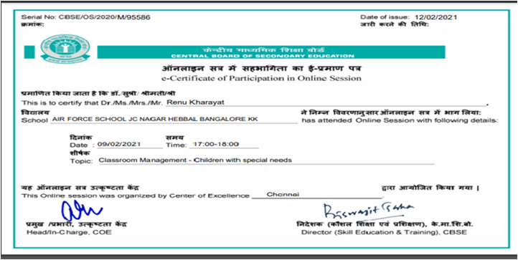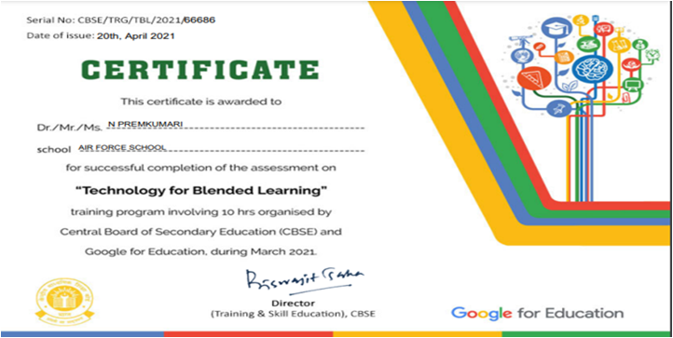

Class room management- Children with special needs Technology with blended learning

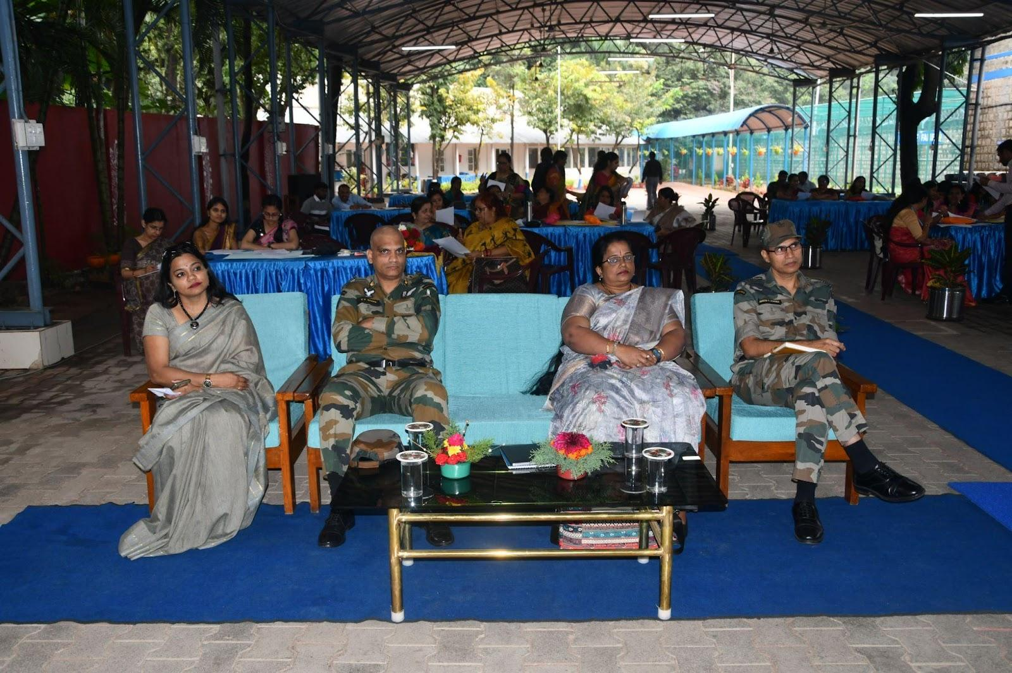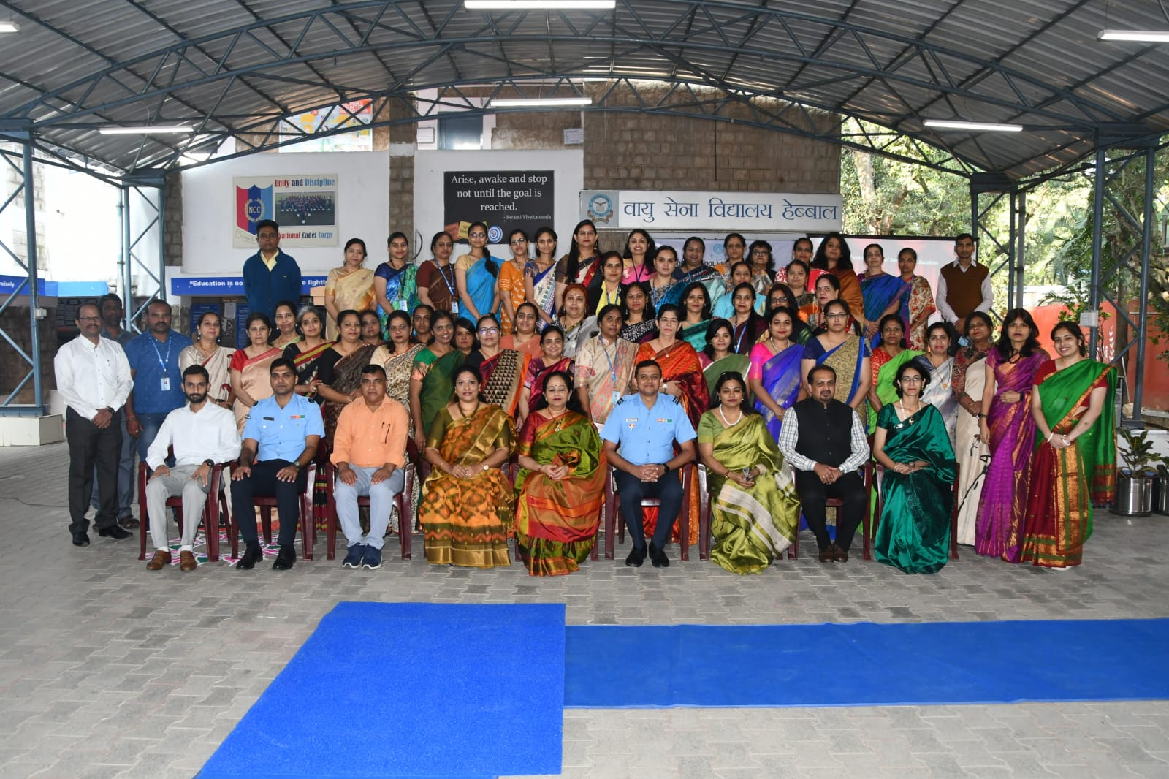

In-house workshop on Life Skills In-house workshop on Value Education
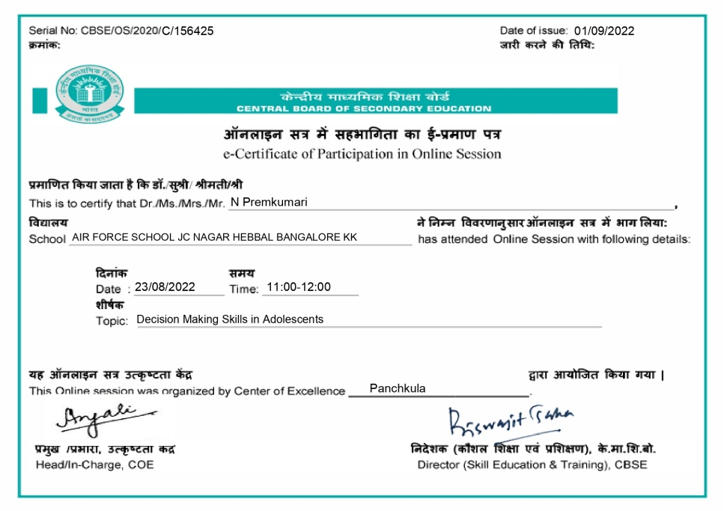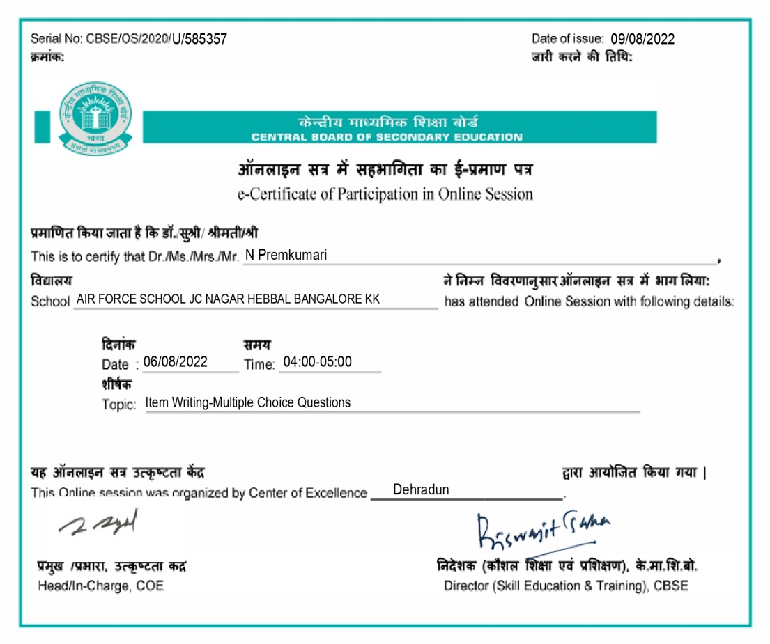

Decision Making skills in Adolescents Item Writing Multiple Choice Questions
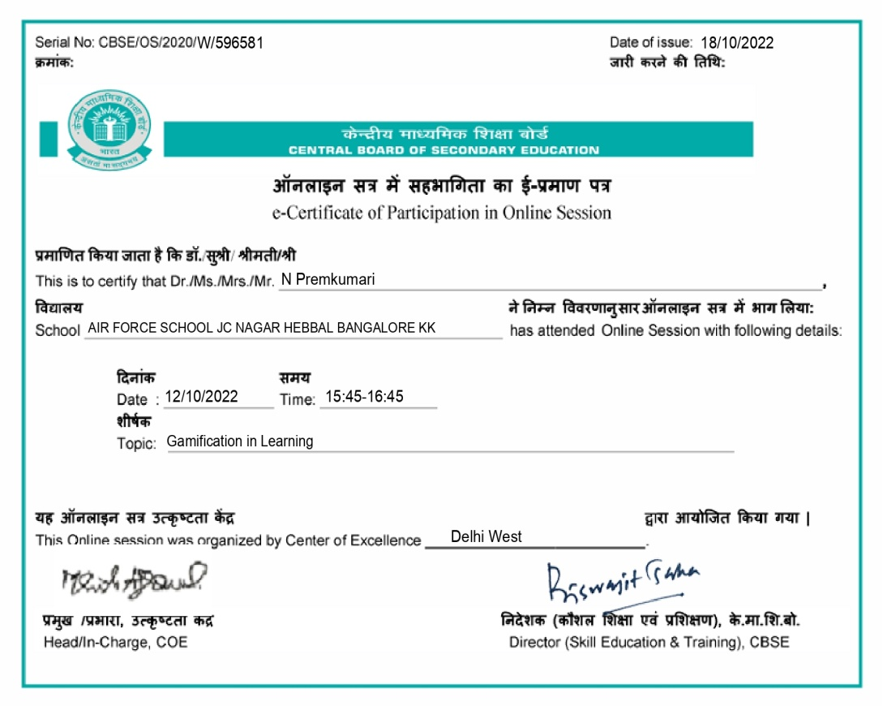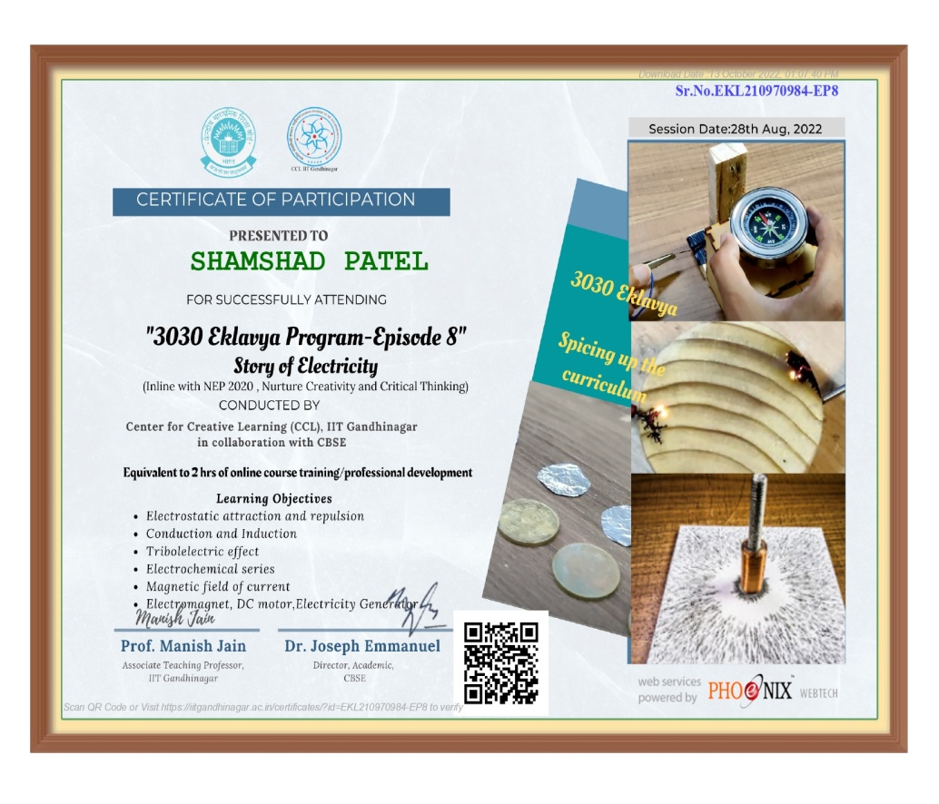

Gamification in Learning Eklavya
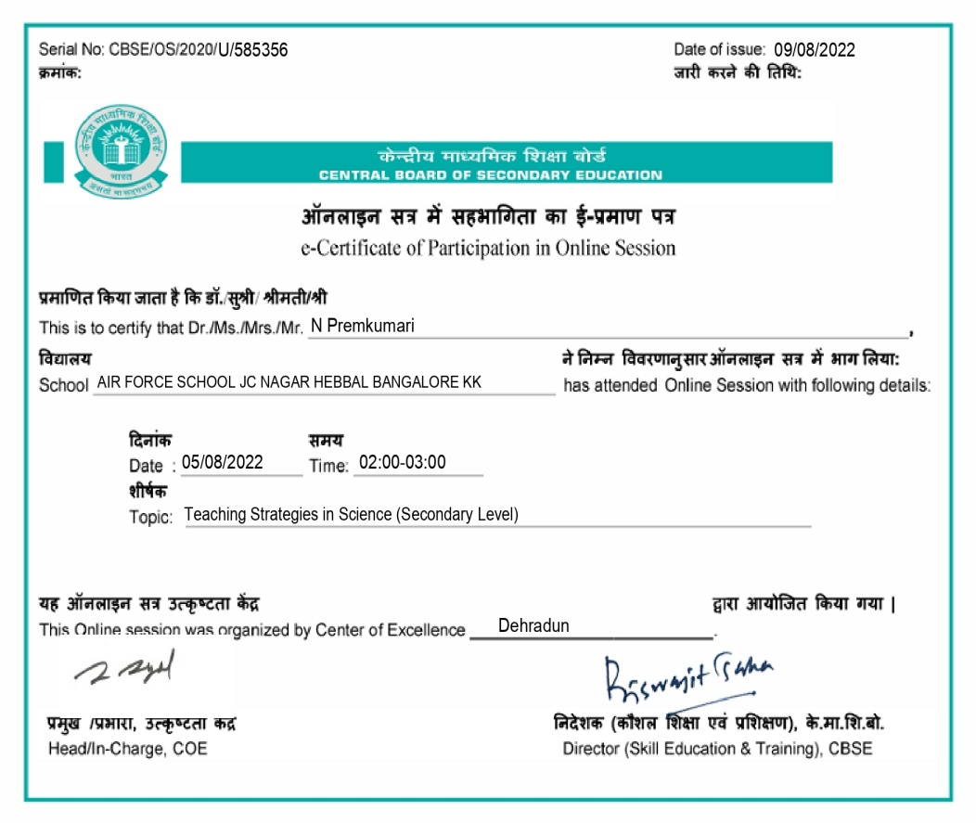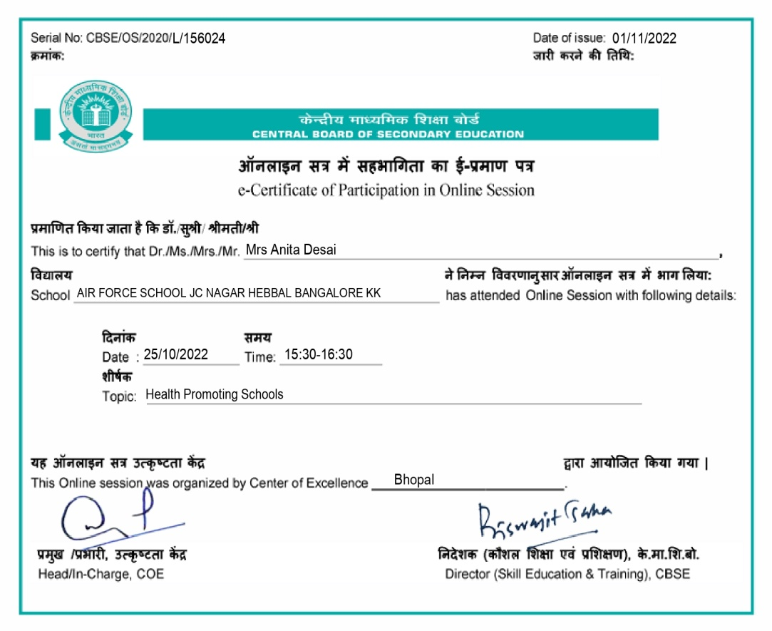

Teaching Strategies in Science Health Promoting Schools

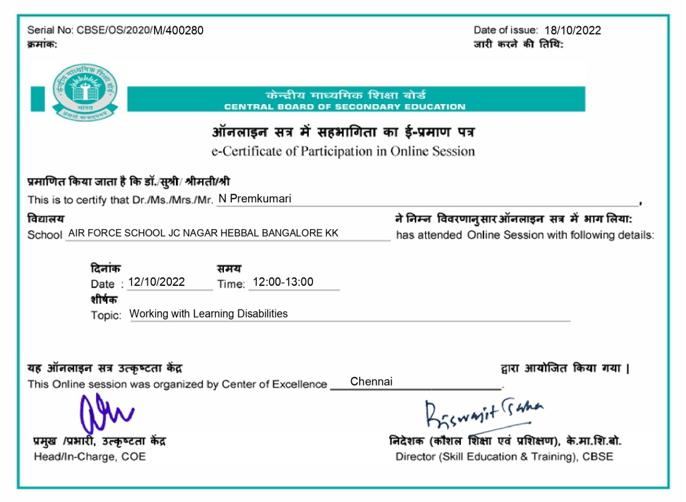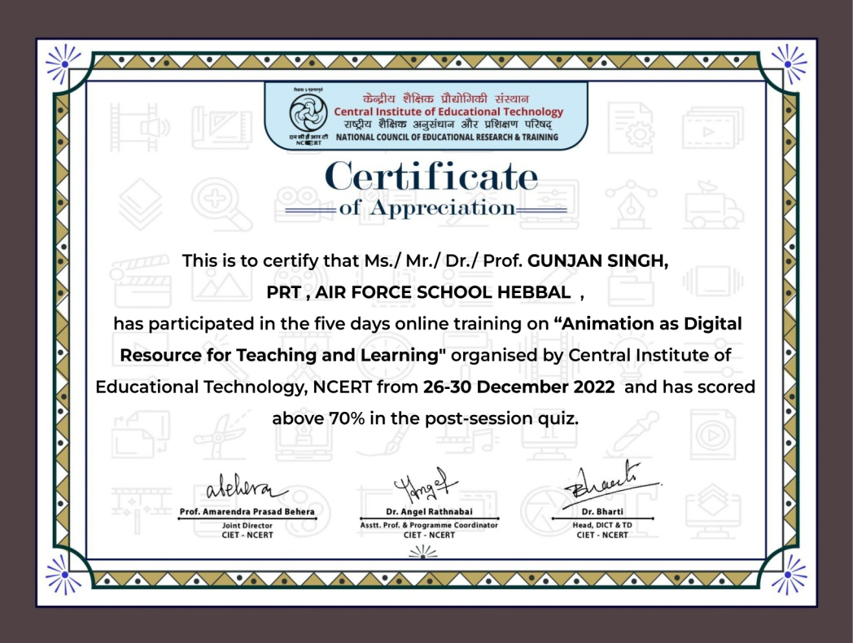

Working with Learning Disabilities Animation as Digital Resource for Teaching and Learning
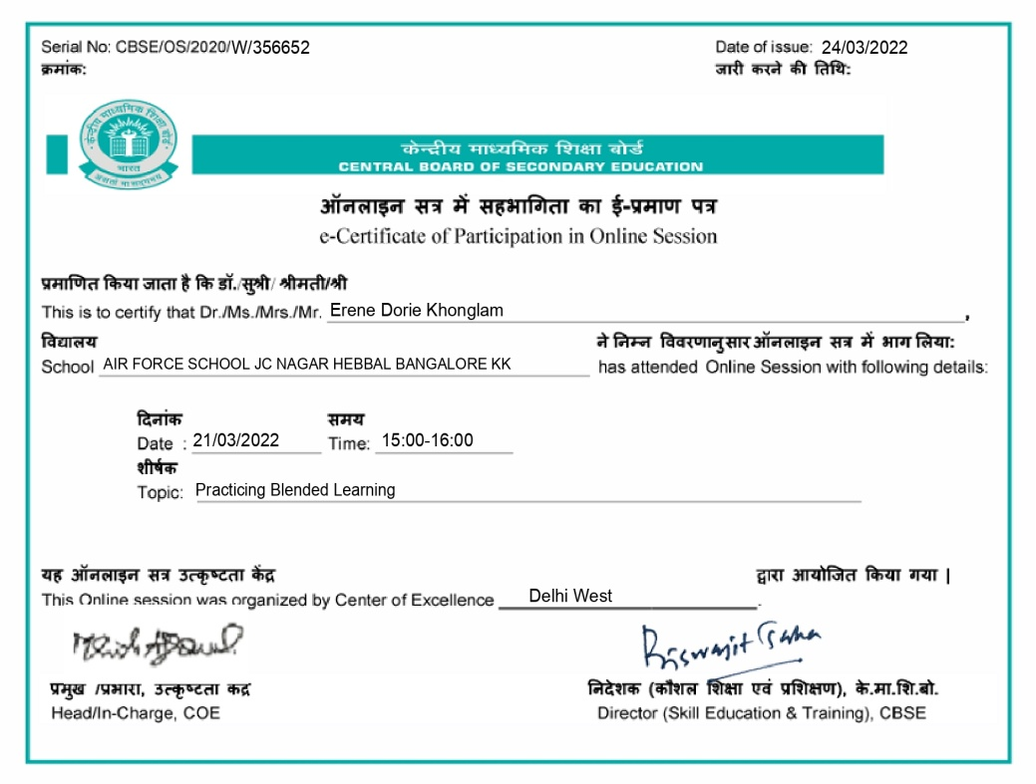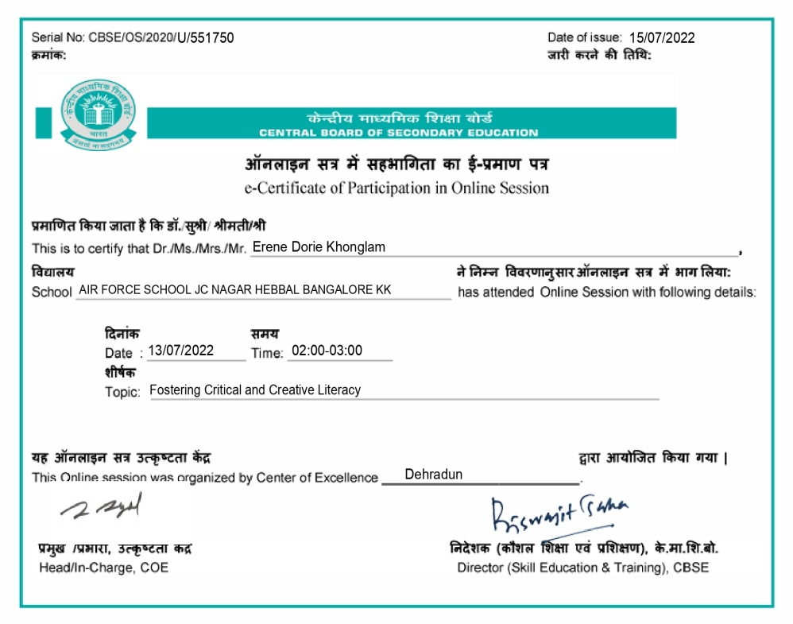

Practicing Blended Learning Fostering Critical And Creative Literacy
ACADEMIC ACHIEVEMENTS

SCIENCE STREAM
SUBJECT | A1 | A2 | B1 | B2 | C1 | C2 | D1 | D2 | TOTAL STUDENTS APPEARED | TOTAL STUDENTS PASSED
English | 18 | 20 | 6 | 3 | 2 | 0 | 0 | 0 | 49 | 49
Maths | 15 | 6 | 6 | 5 | 3 | 3 | 2 | 2 | 42 | 42
Physics | 15 | 12 | 12 | 5 | 5 | 0 | 0 | 0 | 49 | 49
Chemistry | 15 | 11 | 7 | 6 | 6 | 4 | 0 | 0 | 49 | 49
Biology | 5 | 8 | 4 | 2 | 1 | 0 | 0 | 0 | 20 | 20
Physical Education | 9 | 2 | 1 | 0 | 1 | 0 | 0 | 0 | 13 | 13
Computer Science | 13 | 2 | 3 | 0 | 4 | 0 | 0 | 0 | 22 | 22
Psychology | 0 | 0 | 1 | 0 | 0 | 0 | 0 | 0 | 1 | 1
OVERALL TOPPER | KARPURAPU ANIKET = 97.2%

COMMERCE STREAM
SUBJECT | A1 | A2 | B1 | B2 | C1 | C2 | D1 | D2 | TOTAL STUDENTS APPEARED | TOTAL STUDENTS PASSED
English | 4 | 6 | 2 | 2 | 2 | 1 | 0 | 0 | 17 | 17
Economics | 8 | 3 | 3 | 3 | 0 | 0 | 0 | 0 | 17 | 17
Business Studies | 8 | 4 | 2 | 0 | 2 | 1 | 0 | 0 | 17 | 17
Accountancy | 3 | 6 | 2 | 2 | 1 | 2 | 1 | 0 | 17 | 17
Mathematics | 0 | 0 | 1 | 1 | 0 | 1 | 0 | 0 | 3 | 3
Physical Education | 6 | 4 | 1 | 1 | 0 | 0 | 0 | 0 | 12 | 12
Computer Science | 1 | 1 | 0 | 0 | 0 | 0 | 0 | 0 | 2 | 2
OVERALL TOPPER | C SIDDHARTHA - 97.8 %

HUMANITIES STREAM
SUBJECT | A1 | A2 | B1 | B2 | C1 | C2 | D1 | D2 | TOTAL STUDENTS APPEARED | TOTAL STUDENTS PASSED
English | 3 | 2 | 2 | 1 | 0 | 1 | 0 | 0 | 9 | 9
History | 7 | 0 | 1 | 0 | 1 | 0 | 0 | 0 | 9 | 9
Political Science | 3 | 4 | 1 | 0 | 0 | 0 | 0 | 1 | 9 | 9
Economics | 2 | 2 | 0 | 0 | 0 | 0 | 0 | 0 | 4 | 4
Psychology | 1 | 0 | 1 | 1 | 1 | 0 | 0 | 1 | 5 | 5
Physical Education | 1 | 1 | 0 | 0 | 0 | 1 | 0 | 0 | 3 | 3
Legal Studies | 0 | 0 | 0 | 0 | 5 | 0 | 1 | 0 | 6 | 6
OVERALL TOPPER | JOEL VARGHEESE KOSHY = 90.8%

CLASS X 2022-23
SUBJECT | 91-100 | 81-90 | 71-80 | 61-70 | 51-60 | 41-50 | 33-40 | Bl 33 | TOTAL STUDENTS APPEARED | TOTAL STUDENTS PASSED
ENGLISH | 18 | 26 | 19 | 15 | 1 | 0 | 0 | 0 | 79 | 79
HINDI | 12 | 26 | 12 | 13 | 15 | 0 | 0 | 0 | 78 | 78
ART | 0 | 0 | 0 | 0 | 0 | 0 | 0 | 0 | 0 | 0
MATHEMATICS | 1 | 17 | 5 | 12 | 12 | 20 | 11 | 0 | 78 | 78
MUSIC | 0 | 0 | 1 | 0 | 0 | 0 | 0 | 0 | 1 | 1
SCIENCE | 17 | 10 | 14 | 11 | 18 | 8 | 1 | 0 | 79 | 79
SOCIAL STUDIES | 32 | 16 | 9 | 14 | 8 | 0 | 0 | 0 | 79 | 79
INFORMATION TECHNOLOGY | 11 | 9 | 10 | 1 | 0 | 0 | 0 | 0 | 31 | 31
RETAIL | 6 | 4 | 0 | 0 | 0 | 0 | 0 | 0 | 10 | 10
ARTIFICIAL INTELLIGENCE | 34 | 4 | 0 | 0 | 0 | 0 | 0 | 0 | 38 | 38
OVERALL TOPPER | KSHITISH RAJ DWIVEDI = 94.2%

STUDENTS APPLIED FOR NDA Batch 2022 -2023
- Aryan Kumar Arya
- Vinay Deshpandey
- Galaba Vamsi
- Karpurapu Aniket Kumar
- Akshat Tripathi
- L Gyan Rao Nazre

EFFORTS MADE IN THE FIELD OF ENVIRONMENT EDUCATION
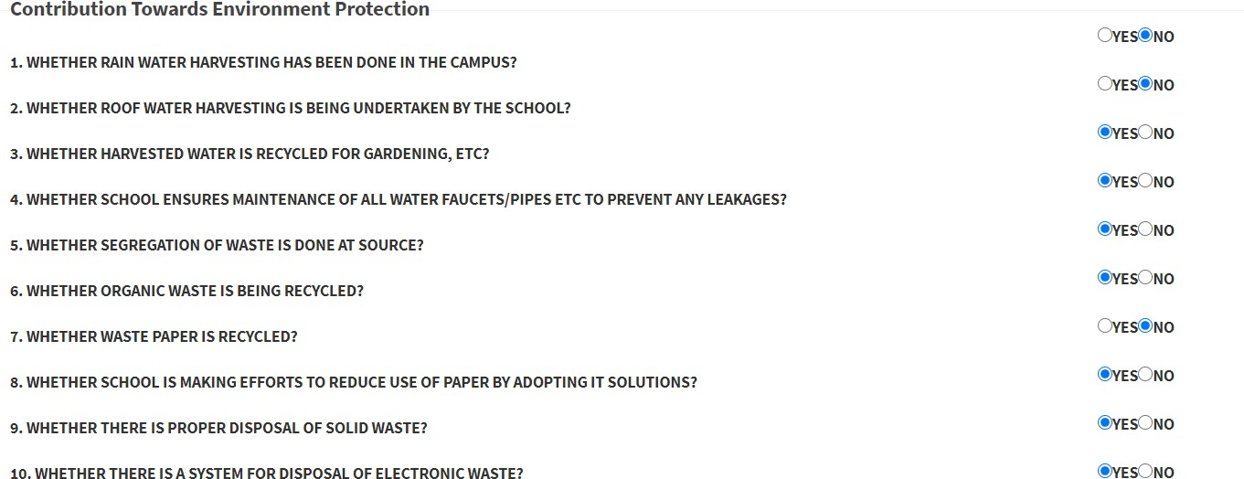

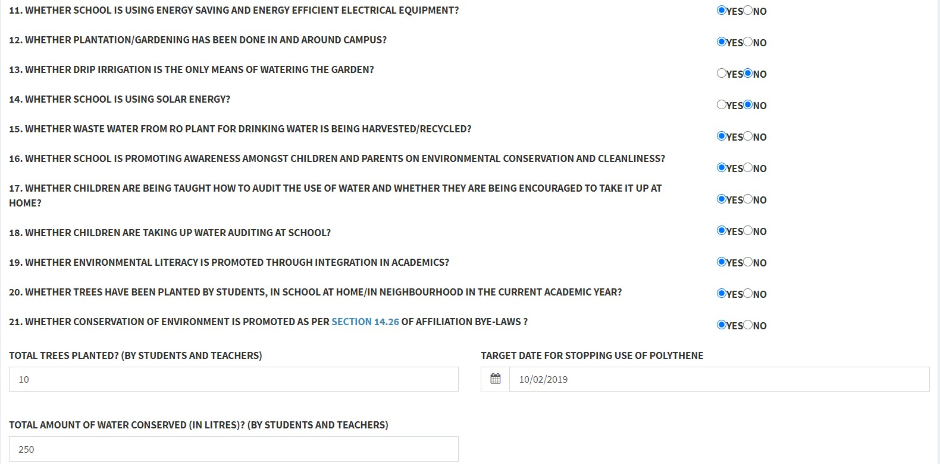
SPORTS ACHIEVEMENT

Tanvi.S
Karnataka Second Mini Olympic 2022
  - Gold
  - 23 Sub-Junior National Championship 2022 - Silver

AKSHAYA. R. SHET

State Sub-Junior and Junior Swimming Championship U-17 2022
- 200m Backstroke – Silver
- 100m Backstroke – Silver
- 100m Freestyle – Silver

Praticipation
- Participated in Khelo India 2022
- Visited Seychelles in East Africa to participate in International Open Water Meet

CBSE sports achievements
- 5- Gold Medals in CBSE swimming South Zone II 2022-23,NPS AGARA Bangalore
- 2- Gold Medals in CBSE National Swimming Competition 2022-23, Rajkot Gujarat

SAIESH KINNI

Aeries Swim Meet 2022
- 2– Silver

CBSE sports achievements

- 1- Bronze in CBSE swimming South Zone II 2022-23,NPS AGARA Bangalore

HARSHAL SINGH
- 1- Bronze in CBSE cluster athletics championship 2022-23 Mangalore

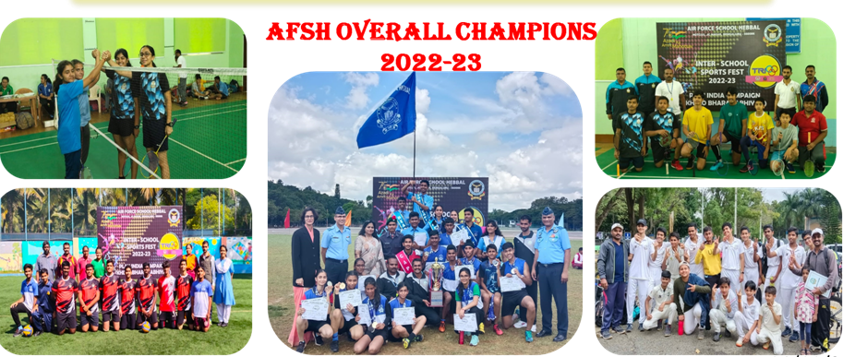

OVER ALL CHAMPIONSHIP – TRI SCHOOL FEST

NCC – 2022-23

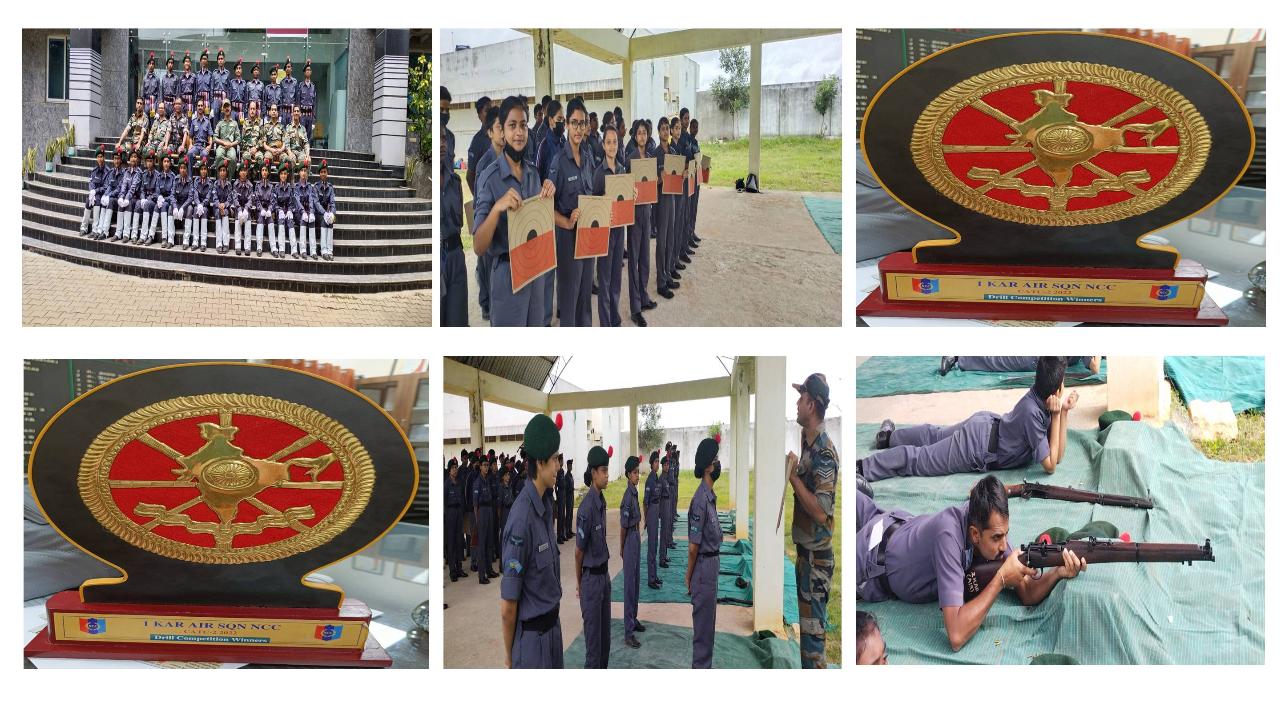

Combined Annual Training Camp conducted by 1KAR AIR SQN NCc from 18 August to 24 August. Selected NCC candidates praticipated in various events like Drilling and Marching, Tug of War,Throw Ball, Poster making competion,Eassy writting and etc.and also won Over All Championship Trophy
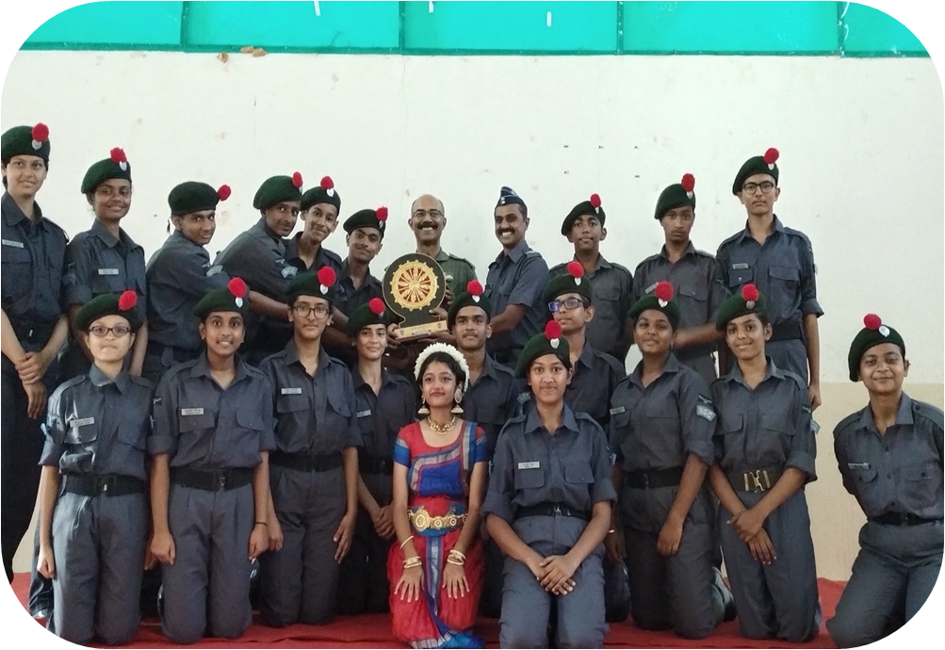

INNOVATIONS

March 2022 onwards: Activities in ATL:
By Ms.LEELAMIBKA
ATL Incharge, AFS Hebbal
The academic activity in ATL for the year 2022-23 started with ATL community day students from two orpanages visited our school to celebrate the Community Day and enjoyed a series of events that was arranged to them.
The following events which was conducted as apart of ATL activities are as follows
1.ATL Gadget Making - Tod Pod Jhod
The students from all the four houses competed to build, re-construct, innovate over the old electronic components mthebest use of these provided components like the old projector, camera, fans, motors, PCB, mother boards, CPU etc. They thoroughly enjoyed opening up the same and look how it works inside out to brainstorm on putting these things in use in the best possible way. The event was conducted from 21st April 2022 to 25th April 2022
2 Tinkerpreneu r 2022 was conducted in the month of May- hosted by AIM

3 ATL marathon was conducted in the month of September –hosted by AIM

4 Seed the Future Entrepreneurs Programme - hosted by La Fondation Dassault Systems India in collaboration with AIM

5 Tinker champ club – student led initiative – digital skilling bootcamp

OVERALL RESULTS
CBSE XII – 2020-2021

SCIENCE STREAM
SUBJECT | A1 | A2 | B1 | B2 | C1 | C2 | D1 | D2 | TOTAL STUDENTS APPEARED | TOTAL STUDENTS PASSED
English | 18 | 20 | 6 | 3 | 2 | 0 | 0 | 0 | 49 | 49
Maths | 15 | 6 | 6 | 5 | 3 | 3 | 2 | 2 | 42 | 42
Physics | 15 | 12 | 12 | 5 | 5 | 0 | 0 | 0 | 49 | 49
Chemistry | 15 | 11 | 7 | 6 | 6 | 4 | 0 | 0 | 49 | 49
Biology | 5 | 8 | 4 | 2 | 1 | 0 | 0 | 0 | 20 | 20
Physical Education | 9 | 2 | 1 | 0 | 1 | 0 | 0 | 0 | 13 | 13
Computer Science | 13 | 2 | 3 | 0 | 4 | 0 | 0 | 0 | 22 | 22
Psychology | 0 | 0 | 1 | 0 | 0 | 0 | 0 | 0 | 1 | 1
OVERALL TOPPER | KARPURAPU ANIKET = 97.2%

COMMERCE STREAM
SUBJECT | A1 | A2 | B1 | B2 | C1 | C2 | D1 | D2 | TOTAL STUDENTS APPEARED | TOTAL STUDENTS PASSED
English | 4 | 6 | 2 | 2 | 2 | 1 | 0 | 0 | 17 | 17
Economics | 8 | 3 | 3 | 3 | 0 | 0 | 0 | 0 | 17 | 17
Business Studies | 8 | 4 | 2 | 0 | 2 | 1 | 0 | 0 | 17 | 17
Accountancy | 3 | 6 | 2 | 2 | 1 | 2 | 1 | 0 | 17 | 17
Mathematics | 0 | 0 | 1 | 1 | 0 | 1 | 0 | 0 | 3 | 3
Physical Education | 6 | 4 | 1 | 1 | 0 | 0 | 0 | 0 | 12 | 12
Computer Science | 1 | 1 | 0 | 0 | 0 | 0 | 0 | 0 | 2 | 2

HUMANITIES STREAM
SUBJECT | A1 | A2 | B1 | B2 | C1 | C2 | D1 | D2 | TOTAL STUDENTS APPEARED | TOTAL STUDENTS PASSED
English | 3 | 2 | 2 | 1 | 0 | 1 | 0 | 0 | 9 | 9
History | 7 | 0 | 1 | 0 | 1 | 0 | 0 | 0 | 9 | 9
Political Science | 3 | 4 | 1 | 0 | 0 | 0 | 0 | 1 | 9 | 9
Economics | 2 | 2 | 0 | 0 | 0 | 0 | 0 | 0 | 4 | 4
Psychology | 1 | 0 | 1 | 1 | 1 | 0 | 0 | 1 | 5 | 5
Physical Education | 1 | 1 | 0 | 0 | 0 | 1 | 0 | 0 | 3 | 3
Legal Studies | 0 | 0 | 0 | 0 | 5 | 0 | 1 | 0 | 6 | 6
OVERALL TOPPER | JOEL VARGHEESE KOSHY = 90.8%

CLASS X 2022-23
SUBJECT | 91-100 | 81-90 | 71-80 | 61-70 | 51-60 | 41-50 | 33-40 | Bl 33 | TOTAL STUDENTS APPEARED | TOTAL STUDENTS PASSED
ENGLISH | 18 | 26 | 19 | 15 | 1 | 0 | 0 | 0 | 79 | 79
HINDI | 12 | 26 | 12 | 13 | 15 | 0 | 0 | 0 | 78 | 78
ART | 0 | 0 | 0 | 0 | 0 | 0 | 0 | 0 | 0 | 0
MATHEMATICS | 1 | 17 | 5 | 12 | 12 | 20 | 11 | 0 | 78 | 78
MUSIC | 0 | 0 | 1 | 0 | 0 | 0 | 0 | 0 | 1 | 1
SCIENCE | 17 | 10 | 14 | 11 | 18 | 8 | 1 | 0 | 79 | 79
SOCIAL STUDIES | 32 | 16 | 9 | 14 | 8 | 0 | 0 | 0 | 79 | 79
INFORMATION TECHNOLOGY | 11 | 9 | 10 | 1 | 0 | 0 | 0 | 0 | 31 | 31
RETAIL | 6 | 4 | 0 | 0 | 0 | 0 | 0 | 0 | 10 | 10
ARTIFICIAL INTELLIGENCE | 34 | 4 | 0 | 0 | 0 | 0 | 0 | 0 | 38 | 38
OVERALL TOPPER | KSHITISH RAJ DWIVEDI = 94.2%

PTA ACTIVITIES

Parents Teachers Meetings are conducted regularly. Dates are as follows
  - 28 August 2021
  - 30 October 2021
  - 05 February 2022
  - 31 March 2022

NUMBER OF STUDENTS
CLASS | TOTAL NUMBER OF  SECTIONS | TOTAL PER CLASS  INTAKE | TOTAL NUMBER OF  STUDENTS
1 | 03 | 90 | 97
2 | 03 | 90 | 98
3 | 03 | 90 | 97
4 | 03 | 90 | 85
5 | 02 | 90 | 94
6 | 02 | 90 | 88
7 | 02 | 90 | 83
8 | 02 | 90 | 88
9 | 02 | 90 | 83
10 | 02 | 90 | 95
11 | 04 | 75 | 79
12 | 03 | 80 | 69

DECLARATION REGARDING THE CONTENT OF BOOKS

We hereby declare that Air Force School Hebbal follows NCERT Books as prescribed by CBSE. We also declare that some of the books used by the school till class VIII are by Private Publishers. The School Management has gone through the content of the books prescribed and we confirm that the books do not contain any objectionable content that hurts the feeling of any class, community, gender or any religious group in the society.

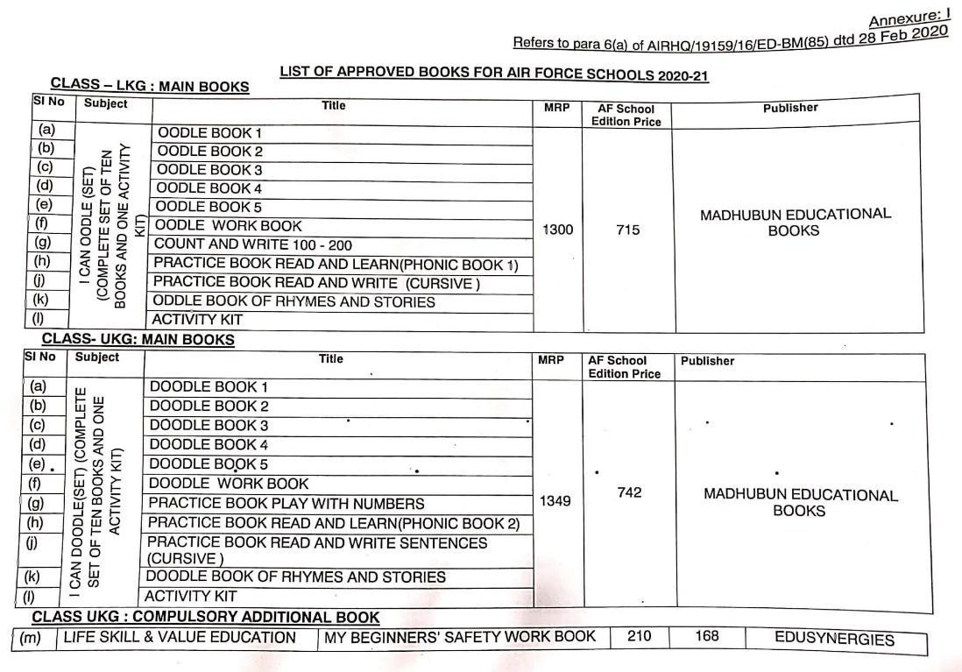

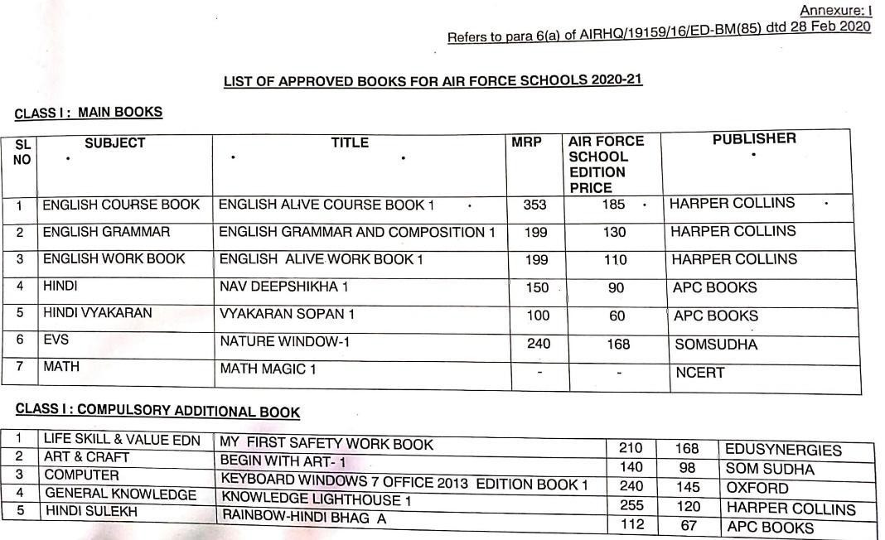
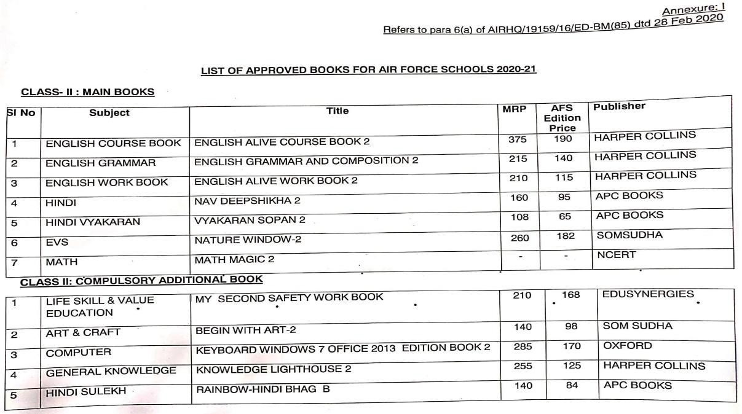

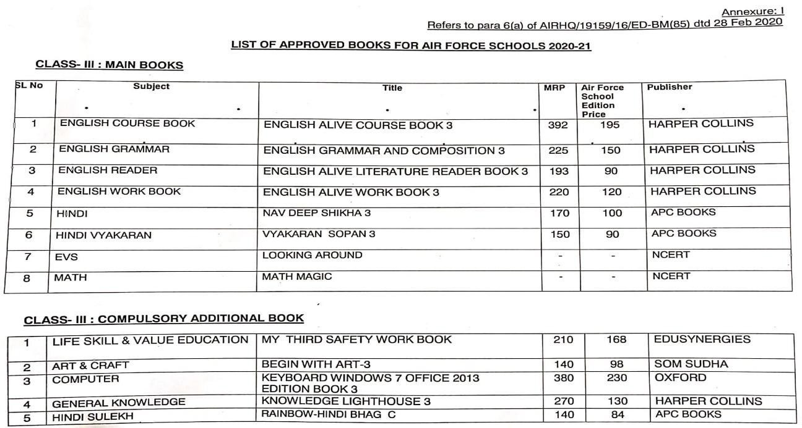
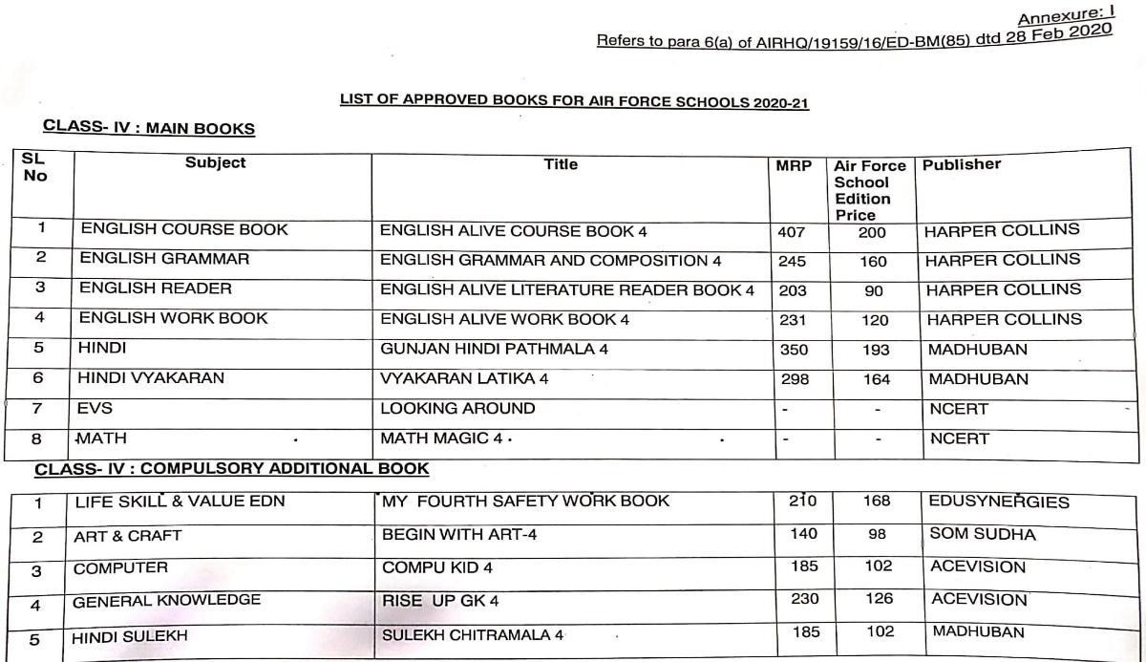
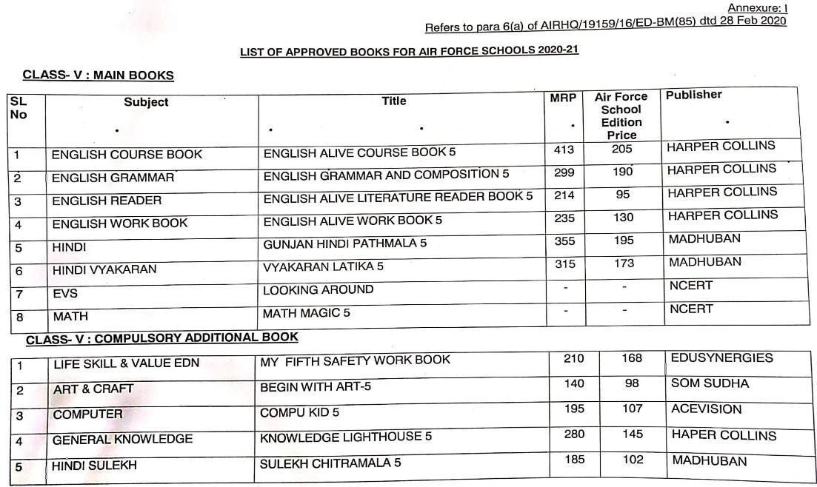

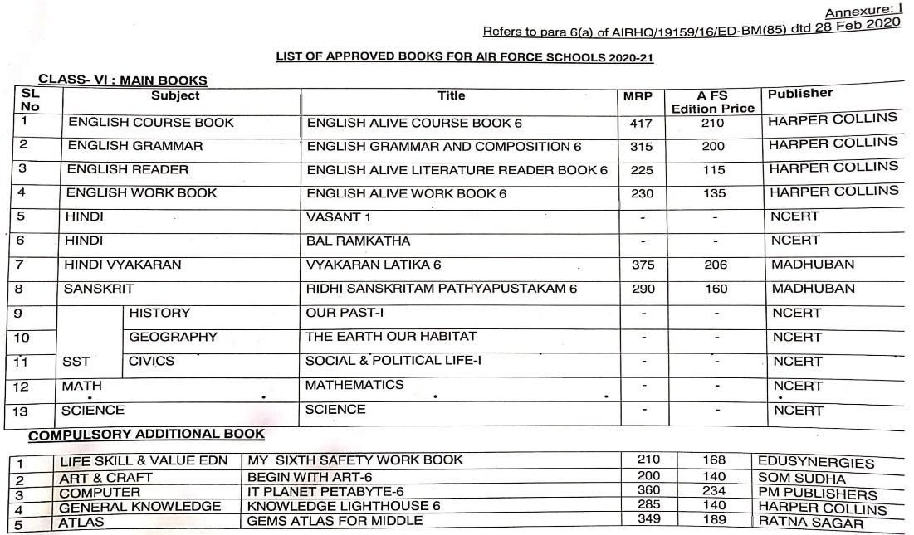
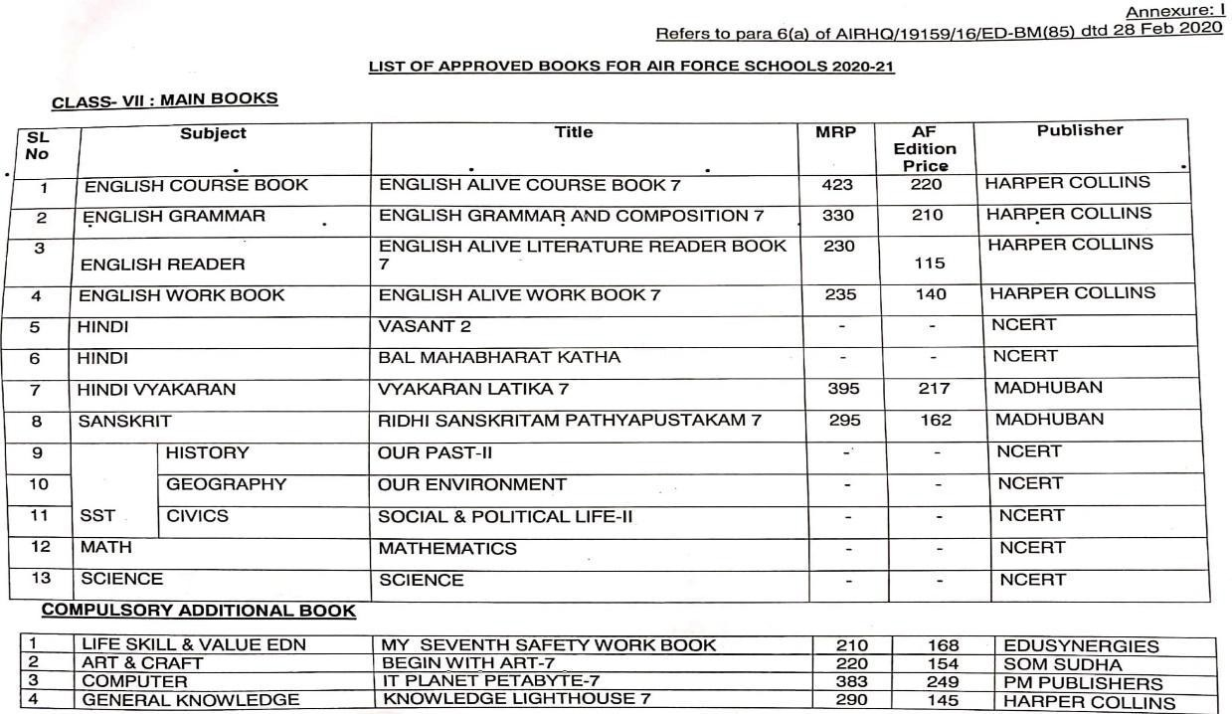

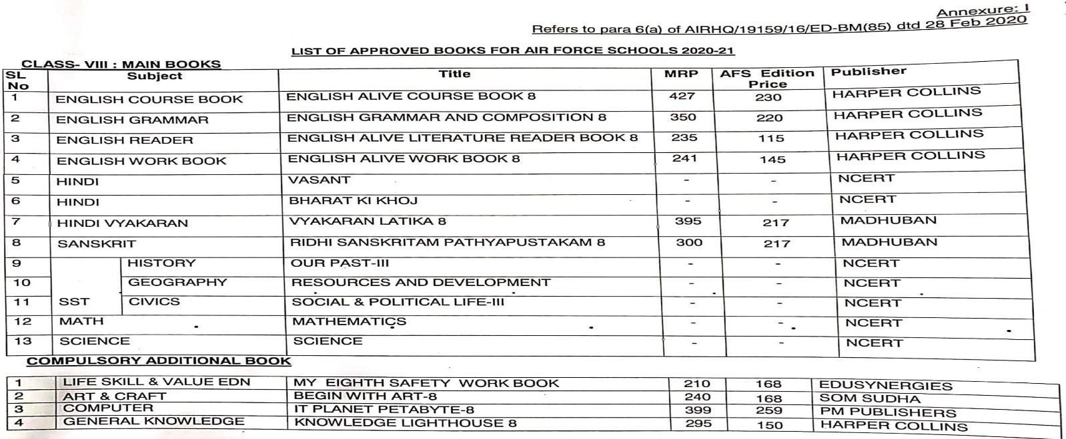

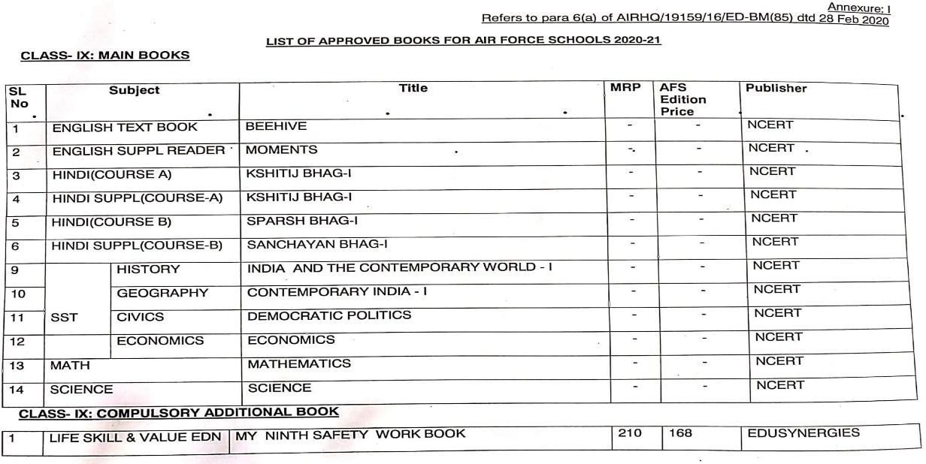
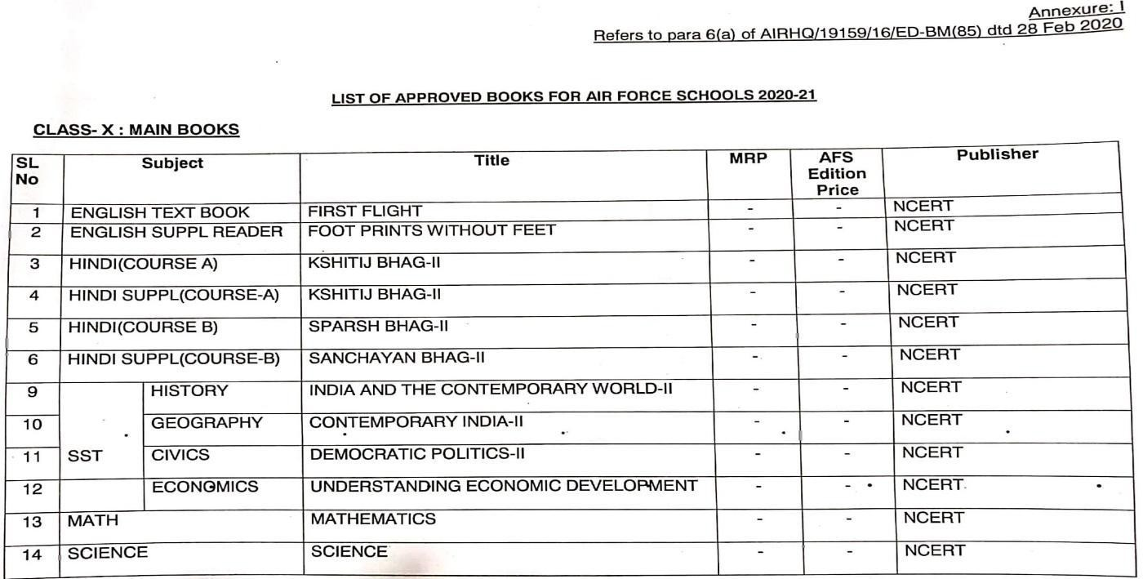

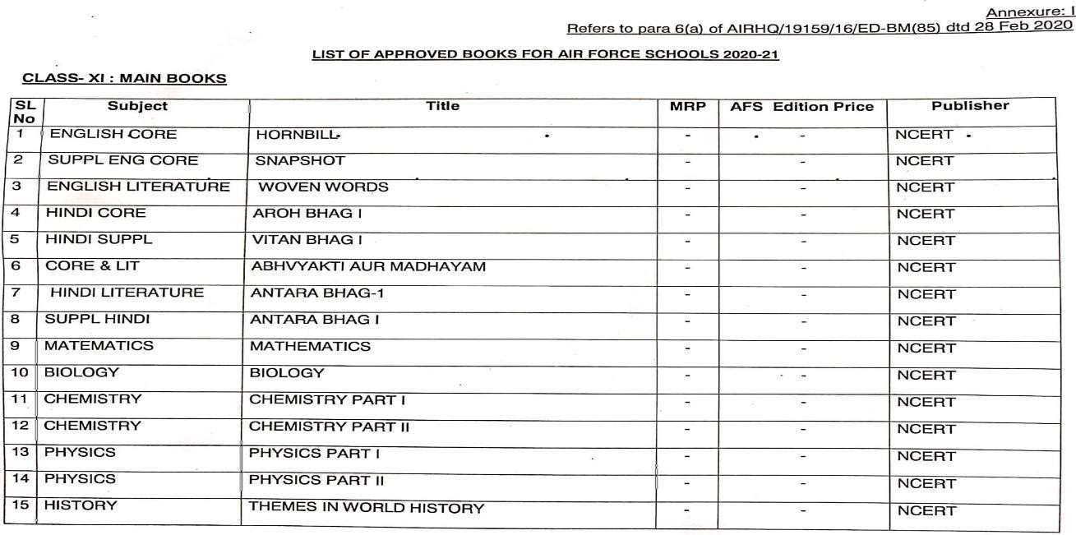

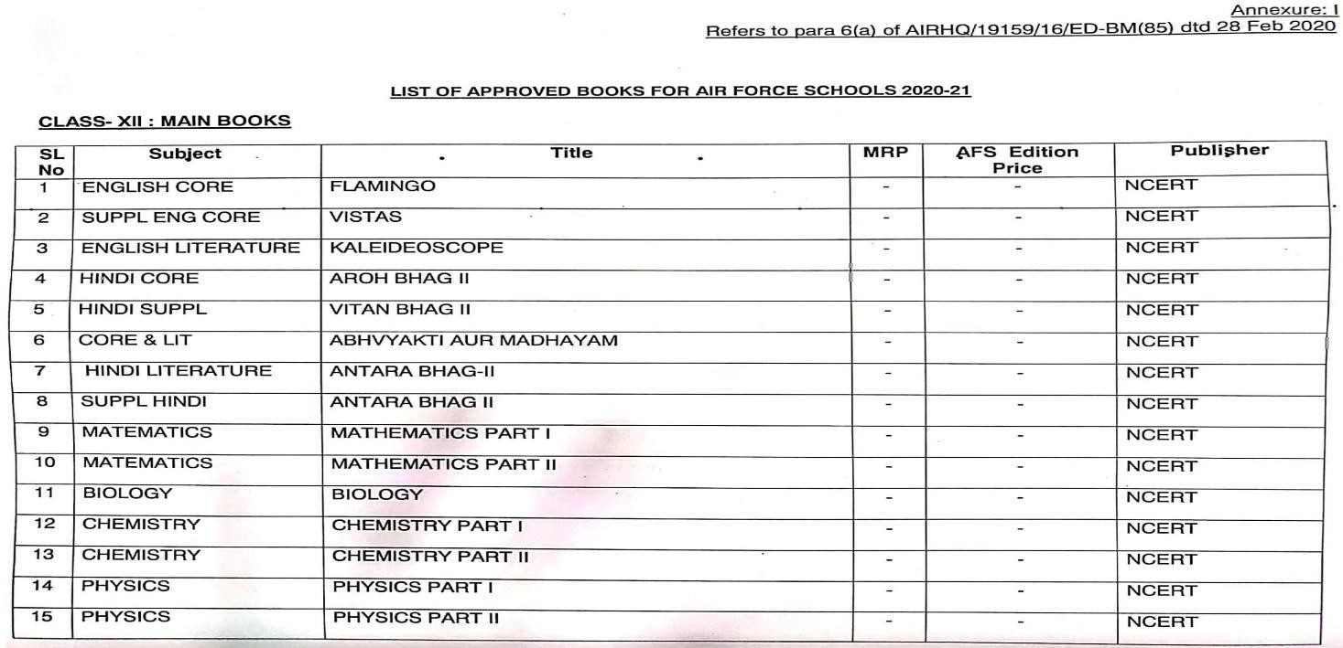

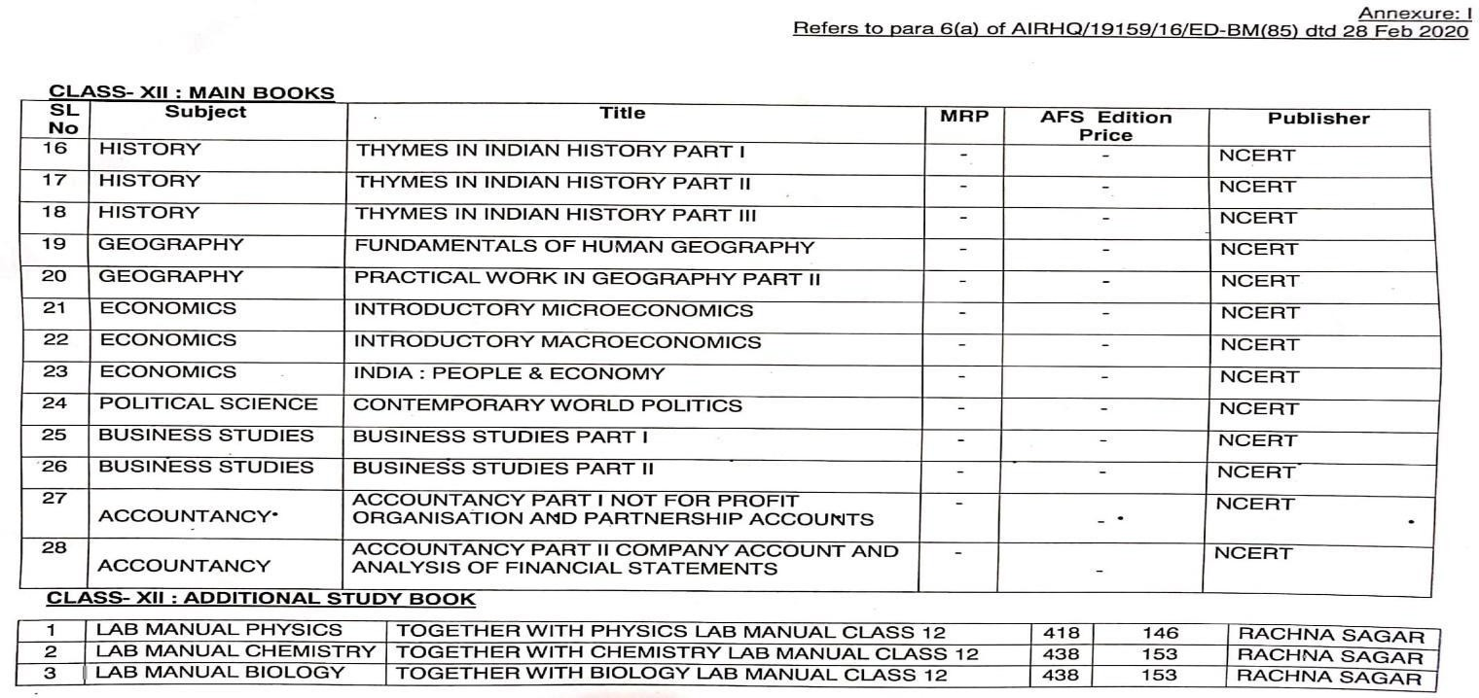

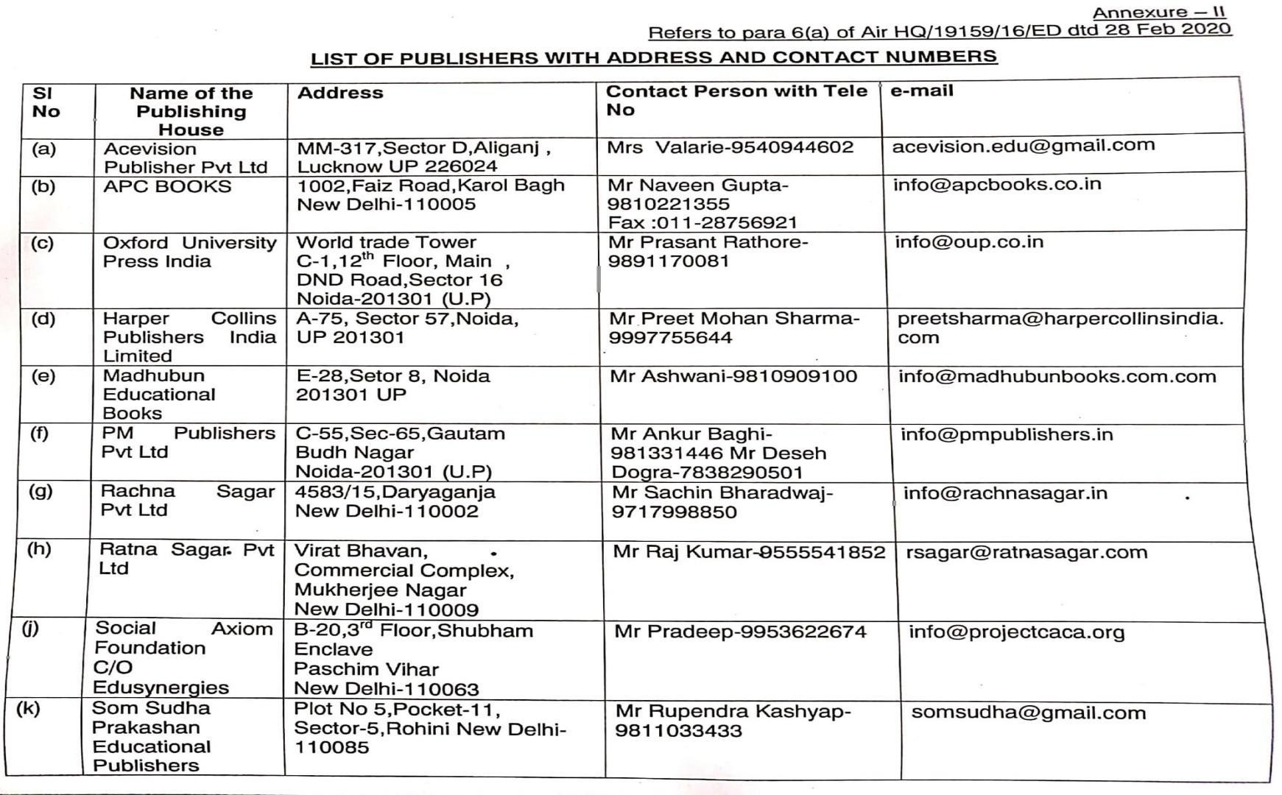

SCHOOL MANAGEMENT COMMITTEE DISCUSSION

- Ratification of all the expenditures, confirmation of staff service.
- Implementation of School ERP and tally accounting software solution on priority.
- Work progress on the old development plan and proposed new development plan.
- Extension of primary and secondary assembly &stage.
- Extension, furnishing and beautification of school office.
- Requirement of kitchen with necessary sink, shelves and washroom near school office.
- Construction of drainage near Primary stage for rain water
- Non-skid tiles to be replaced with the existing ones in front of III C & near Primary staff room corridors.
- Extension of boys & girls washroom in the corridor of V A

